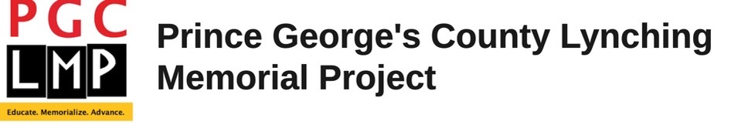

“Intersecting the Past and the Present – Lynching in America”
This webinar focuses on the continued struggle of African Americans and their organizations to fight modern day lynching and examines historical lessons from the past.

Webinar - Thursday, January 20, 2022 – 7pm – 9pm

Panelists:

Nia 2X- Humble - Servant, President of Greater DC Chapter, National Action Network

Qiana Johnson – President and Founder, Life After Release

DaJuan Gay – Alderman, Ward 6 City of Annapolis

Ashanti Martinez – Community Advocate

Moderator: Gabriel Graves - PG County African American Museum

To Register: https://bit.ly/PGCLMP_Jan2022

Sponsors: Prince George’s County NAACP and the Prince George’s County Lynching Memorial Project

